# Eastern Goldfields College 2015

# Mathematical Methods Investigation 2

Out of Class Section

Name:

**TRIG CURVES**

* *The Out of Class Investigation is designed for you to learn the essentials needed for the In-Class validation.*
* *This is the “Take Home” part of the Investigation. It does not count towards your mark for this investigation.*
* *You will need your Casio Classpad.*
* *You are permitted to take this section into the “In Class” validation test to assist you*.

***Date of Validation: Thursday 21th May***.

Shown below is a graph of y = sin x for the domain 0 ≤ x ≤ 6π. It shows the curve as it goes through 3 cycles.

The period is the length of one cycle of the curve. It is often best to measure from maximum to maximum.

The amplitude of a curve is equal to *half* of the distance from the maximum value to the minimum value.

The sine curve below has a period of 2π and an amplitude of 1.

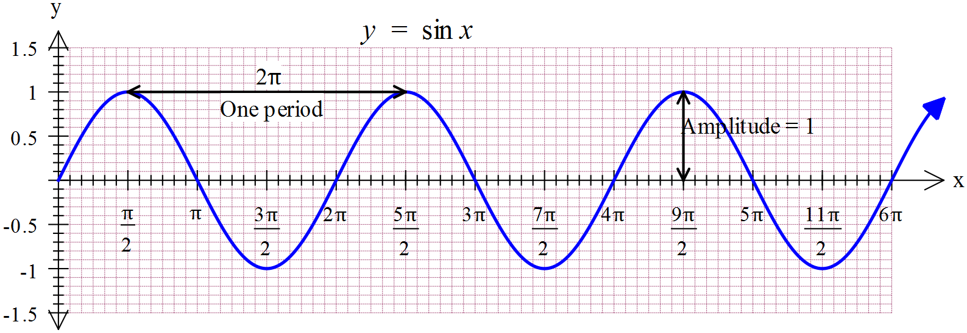

1. Using radians draw a graph of y = cos x between 0 and 4π. Use your calculator to help.

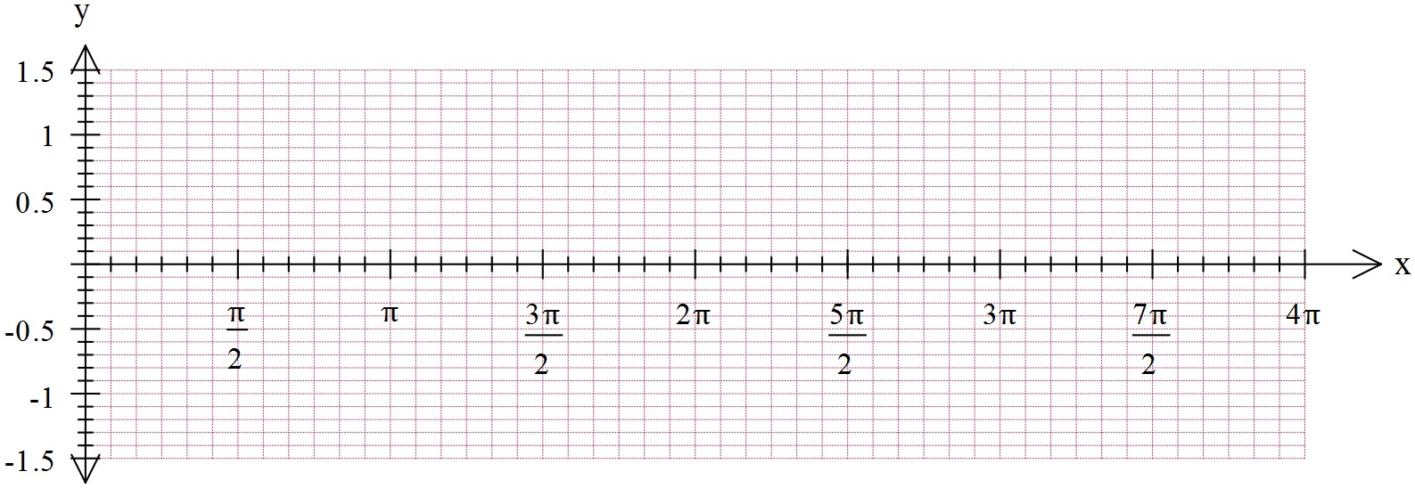

1. State the period of y = cos x and the amplitude of y = cos x.
2. Compare the differences and similarities of y = cos x and y = sin x.
3. Plot the function y = tan x for the domain 0 ≤ x ≤ 3π, indication the presence of vertical asymptotes.

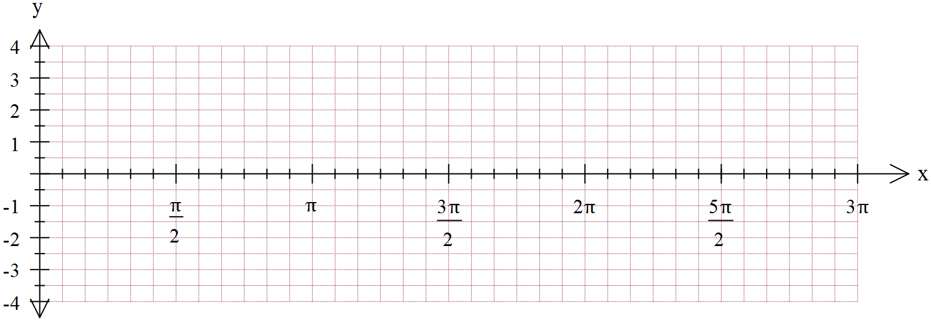

1. State the period of the y = tan x curve.
2. Discuss the amplitude of the y = tan x curve.
3. Plot the curve y = 3 sin x and y = -2 cos x on the axes below.

State the period and amplitude of each.

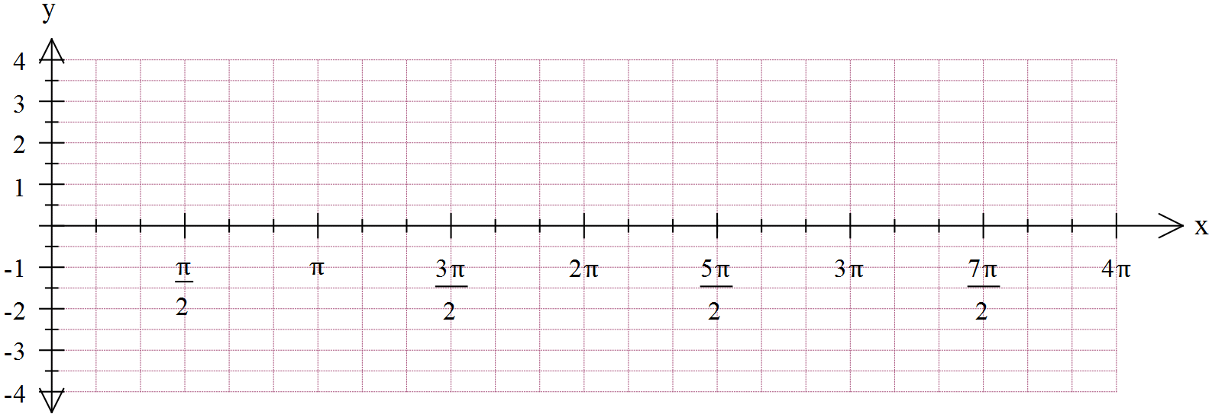



Discuss the transformations that have occurred.

1. Plot the functions y = sin 2x, y = cos 3x and y = sin (. State the amplitude and periods of each.







1. State the effect of b in the rules y = sin bx and y = cos bx.
2. State the period of the functions y = sin 4x, y = cos 0.2x and y = tan 2x.
3. State the rule for the period of y = sin bx and y = cos bx in terms of b: Period = …………………..
4. State the rule for the period of the graph of y = tan bx in terms of b. Period = …………………
5. What is the effect on the sin x graph if it is transformed into y = sin (x +). Draw it below.



1. What is the effect on the cos x graph if it transformed into the rule y = cos (x -)?
2. Draw the graph of y = cos (x - ) below.



1. What is the y = cos (x - ) graph the same as?

Explain why.

1. What is the effect on a sine graph by transforming it into y = sin x + 3. Graph it on your calculator and comment.

(Hint; What will the new mean position be?)

1. Describe what the graph of y = 2cos x – 11 will look like. (Hint; What will the new mean position be?)
2. Putting it all together: Explain the transformations that have occurred to y = cos x to alter it to

y = -4 cos(2x - ) + 3

1. Using the ideas of transformations complete the table for the following trigonometry rules.

Use your calculator if you are not sure.

|  |  |  |  |  |  |  |
| --- | --- | --- | --- | --- | --- | --- |
| Rule | Period | Amplitude | Mean position | Maximum value | Minimum value | Horizontal shift |
| y = 3 sin 2x + 5 | π | 2 | y = 5 | 8 | 2 | none |
| y = -3 cos 3x - 4 |  |  |  |  |  |  |
| y = 0.6 sin (x – 2) + 1.2 |  |  |  |  |  |  |
| y = -2 sin (πx ) - 1 |  |  |  |  |  |  |
| y = tan(0.5x + ) |  |  |  |  |  |  |

1. Find the rules for these graphs.

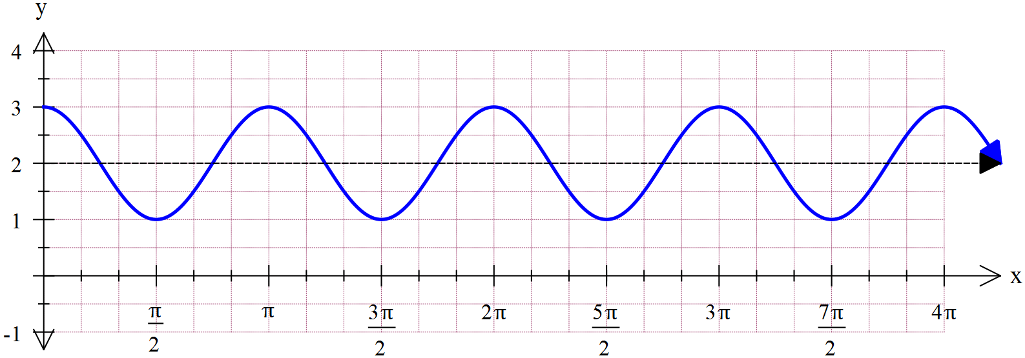

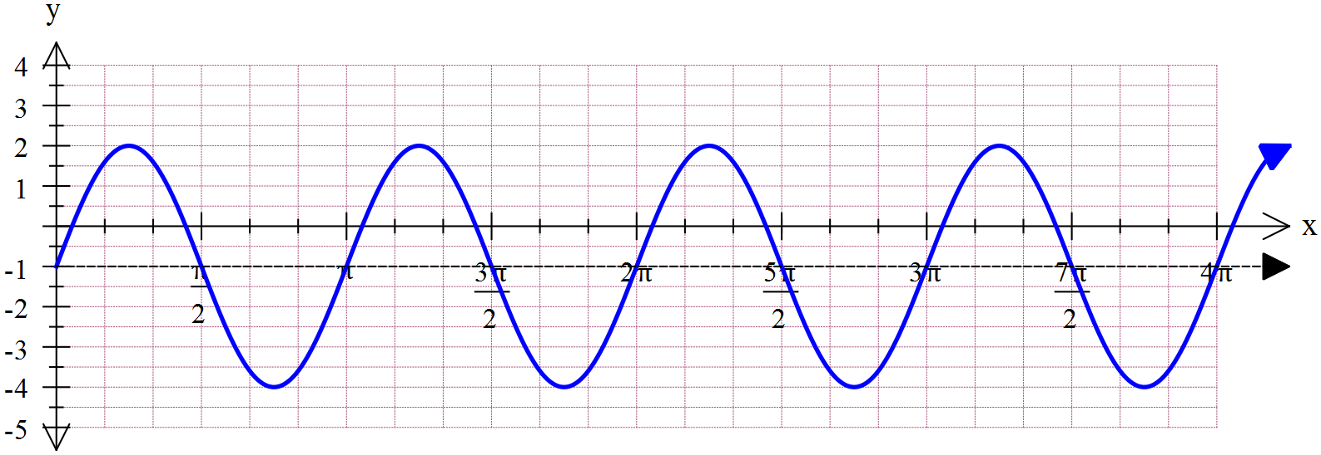

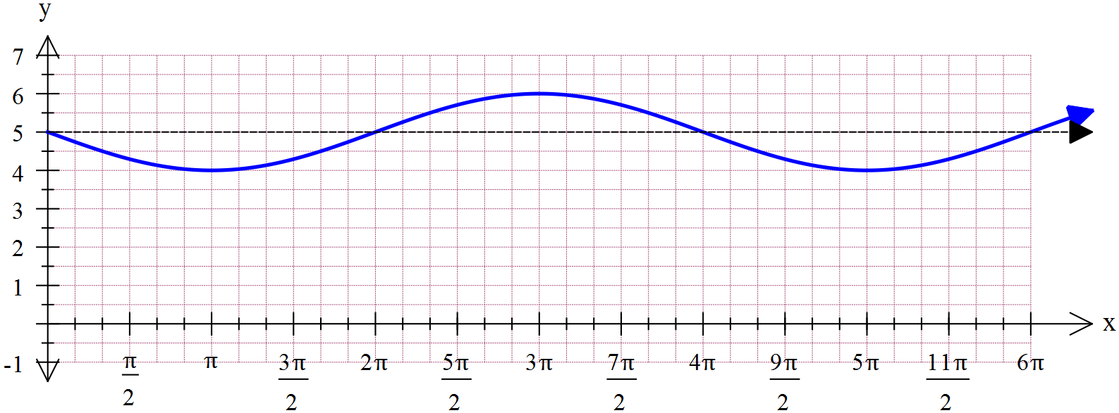

The following questions will show you some examples of how trigonometrical rules are used.

1. Use your calculator and new found knowledge to answer this question.

Tides in a particular harbour are such that the depth of water (in metres) in the harbour is given by:



where t is the number of hours after midnight each day.

(a) At what time does low tide occur each day?

(b) What is the depth of water in the harbour at high tide?

(c) What is the depth of the water in the harbour at 3.00 pm?

(d) What is the maximum and minimum depth of the tide?

(e) Sketch the graph of  for 

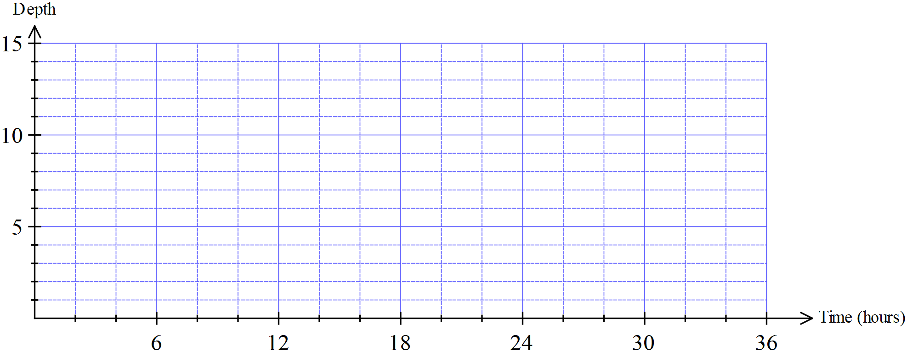

(f) A ship carrying a load has draught (i.e. the depth to which the ship sinks into the water when it is floating) of 10.5 metres.

(i) Show on your graph the times is it possible for the ship to enter the harbour?

(ii) Determine these times, for any day, correct to the nearest minute.

19. The population of a water buffalo herd in the Northern Territory is modelled by:

 where *t* is the number of years since the first estimate was made.

(a) Sketch the graph showing the population for 



(b) Find the maximum herd size and when it occurs

(c) When is the herd size 6000?

20. The ultraviolet radiation rate, , from the sun *t* hours after sunrise on February 14 is modelled by: 

(a) What is the UV rate at sunrise (t = 0)?

(b) Find the greatest and least UV rates

(c) What is the period of the function?

(d) Find when the UV rate is 9.

(e) If sunrise is at 6:15 am, at what time does the maximum UV rate occur?

(f) The most dangerous times for sunburn occur when the UV rate is 12 or above. If sunrise is at 6:15 am, during what times of the day is the UV radiation most dangerous?

(g) Sketch  against time for 



***THE END***